Caterpillar experiment project
Research Question - Will caterpillars survive for 4 weeks in an artificial ecosystem?
Objective: Caterpillars should survive for 4 weeks in an artificial ecosystem.
There are actually 2 different types of caterpillar such as the wax worm and the unknown caterpillar. The first caterpillar was found on plants near one of the observer's lesson place. The observer thought that using this caterpillar for the mean time would be better because it was hard to look for a better caterpillar. The caterpillar should eat the plant where in it’s original habitat. But a lot of the caterpillars and its food were taken by people from it’s original place, the observer should’ve taken more of its food. Without the plant they should be eating, they won’t eat the plant provided that is not from it’s original habitat, because after 5 days, all of them died because of starvation.
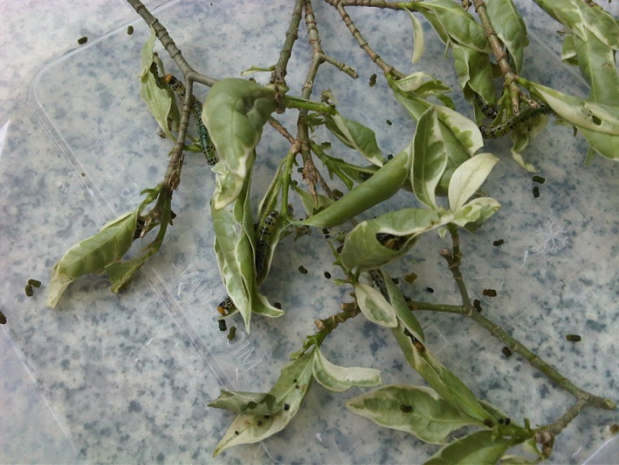

Artificial ecosystem of the first caterpillar

The observer’s group needs to get a new caterpillar and found a caterpillar called the wax worm. This type of caterpillar usually lives on a honeycomb but it can also live in a bamboo and that is why the observer’s group uses bamboo as their artificial ecosystem. Wax worms lives in a warm habitat of 30 degrees Celsius and the humidity should be around 75-85%. Luckily the bamboo can act both as the home and food. At first the observer’s group uses a mixture of baby cereal and honey to keep them alive in the first day but it seems they are so smelly and dirty for their habitat. So the observer decide to use bamboo as they’re food.

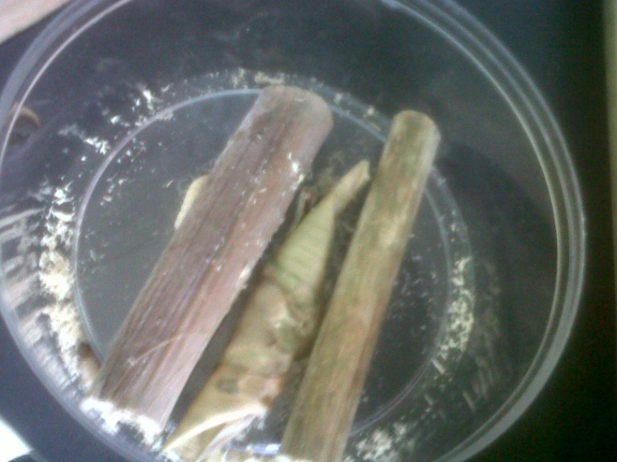
Artificial ecosystem of the second caterpillar

The observer’s group needs to make a hypothesis or a prediction and the group prediction is the caterpillar would survive for 4 weeks. The group plan to make the ecosystem by using a plastic container.

Materials:
- Bamboo tube (2)
- Waxworms (20)
- Candle (1)
- Match (3)
- Tape
Equipments:
- Hard Plastic Container (1) [round or square is fine]
- Nail (3) [however is fine]
- Gauze (size according to hole on top)
- Wet handkerchief (1)
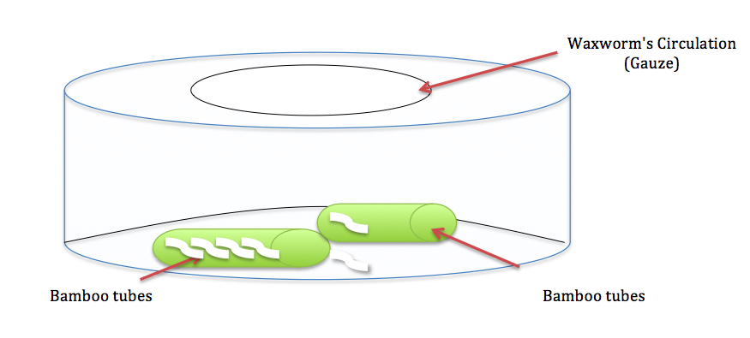
The observer’s sketch of the ecosystem

Below are the procedures:
- Light the candle using the match.
- Using the wet handkerchief to hold the nail, warm it up with the candle
- Push it through the middle of the hard plastic container to make a large hole
- Cover the hole with wire mesh or gauze according to the size
- Use tape to stick it onto the top
- Buy 20 Wax worms inside 2 bamboo tubes.
- Open the end of each bamboo tubes
- Let them out into the plastic container.
- Observe them for three weeks

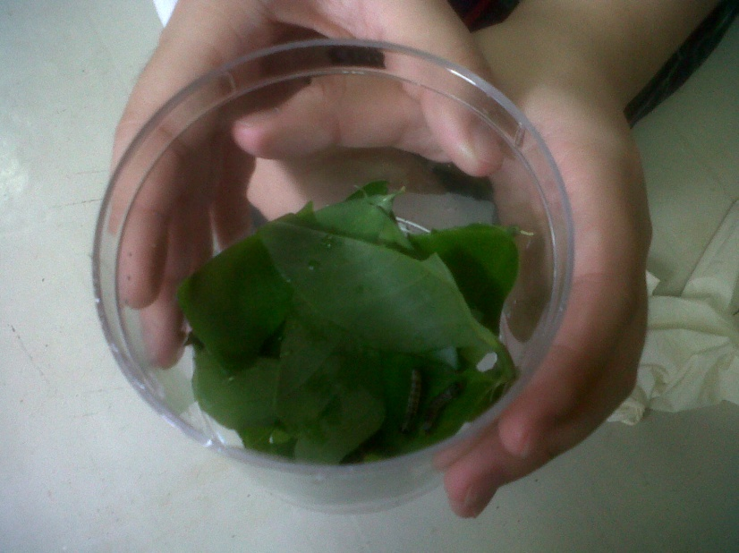
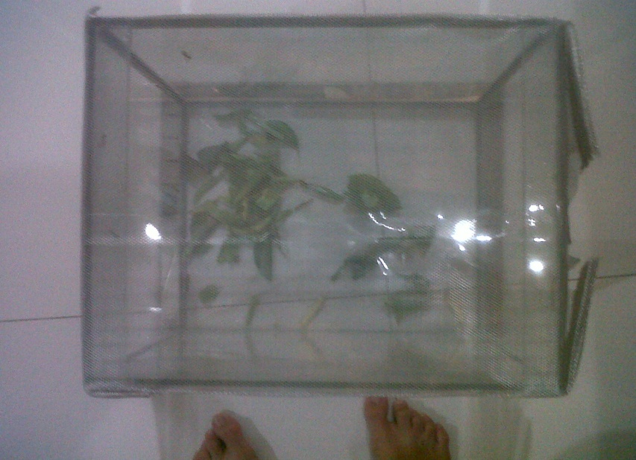
Below are the pictures of the observer’s result throughout the week.

The observer needs to change the habitat into smaller place with more fresh leaves
The first habitat for the first group of caterpillar
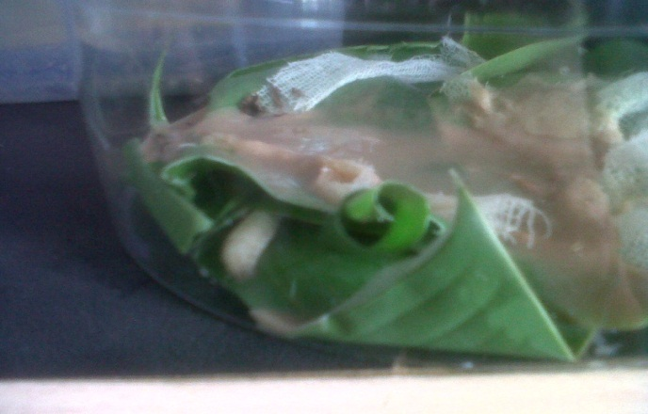
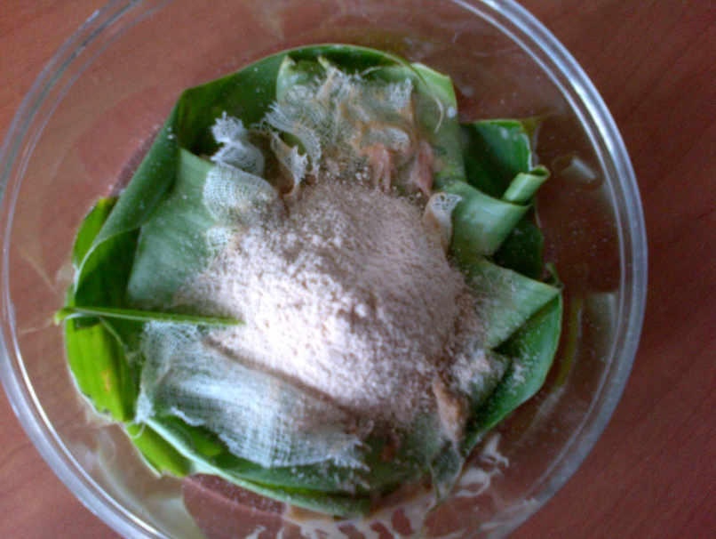

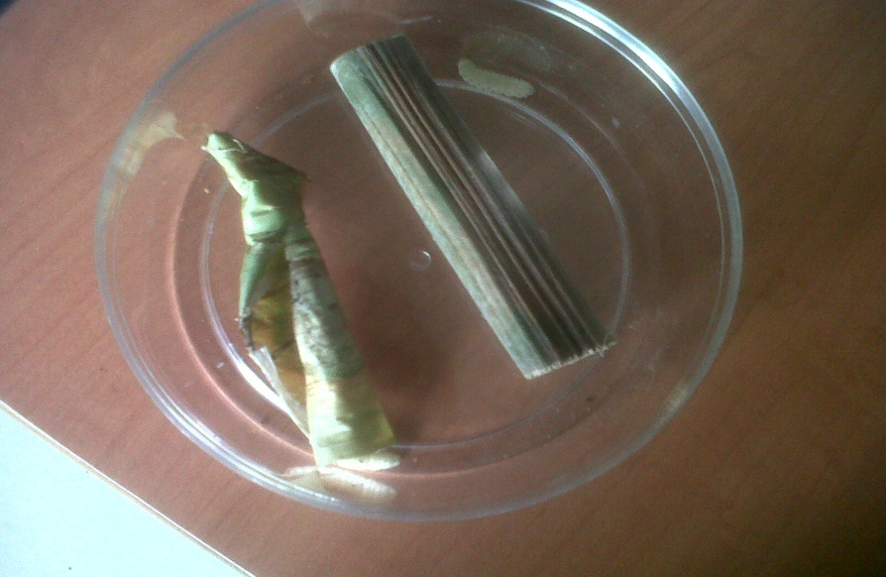
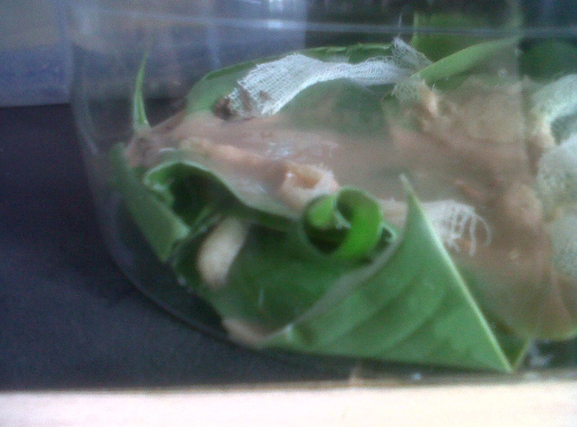
They don’t really eat much of the baby cereal powder. The picture shows what happen to the baby cereal powder after lefted for several days in it’s ecosystem. The baby cereal smells bad and make their habitat dirty which caused to disturb/unconfortable for the wax worms
Baby cereal powder: the food for the wax worms. The food is lefted inside it’s habitat so they could eat it
The result of the baby cereal lefted couple of days
Change the habitat because the baby cereal powder is too smelly and it disturb the caterpillars. The bamboo is a simple habitat more suitable for the caterpillar, and the bamboo could be their food by absorbing the bamboo juices
A group of wax worm (there are still 10 more inside the bamboo)
The powder of baby cereal for the Wax worm’s food
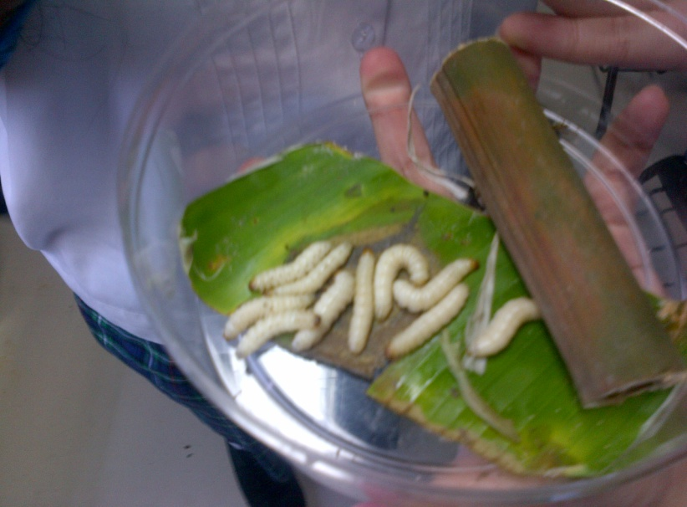

Remove the baby cereal powder from the wax worm’s habitat. Change the habitat because bamboo is more suitable for the caterpillar. The bamboo is more simple (didn’t disturb them at all) and it is warm place for them to stay. The bamboo also included food (bamboo juices), so don’t need to serve them a baby cereal powder anymore.

10 wax worms hiding under the leaves, because the under leaves is a warm and confortable place for them (no lights). A bamboo added, and it contains another 10 caterpillars

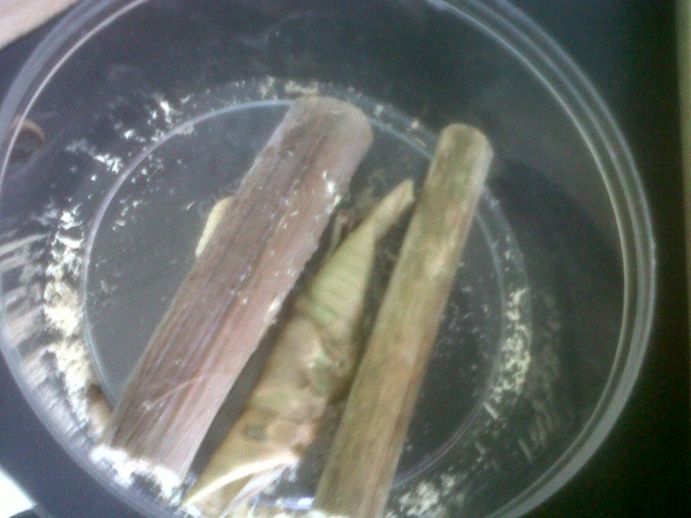
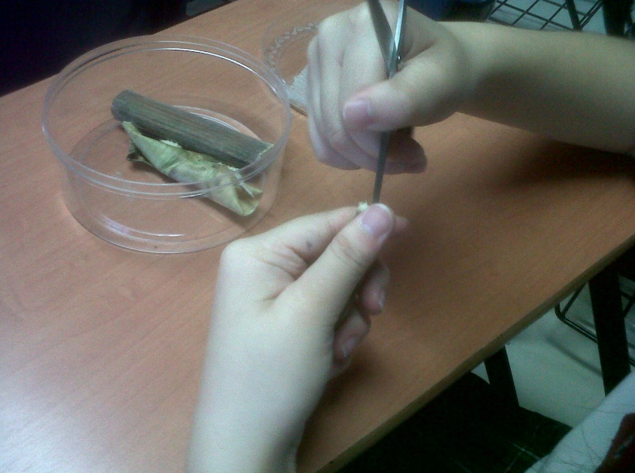

One of the caterpillar has black head after being outside of the bamboo more than a week
One of the observer’s hand trying to make a hole

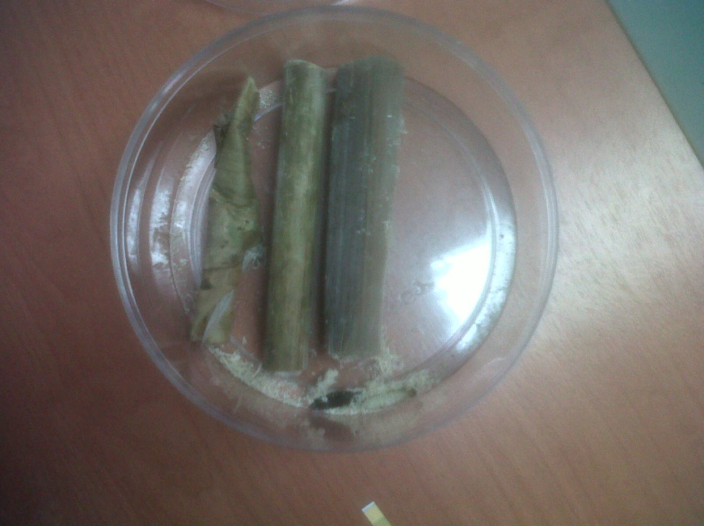
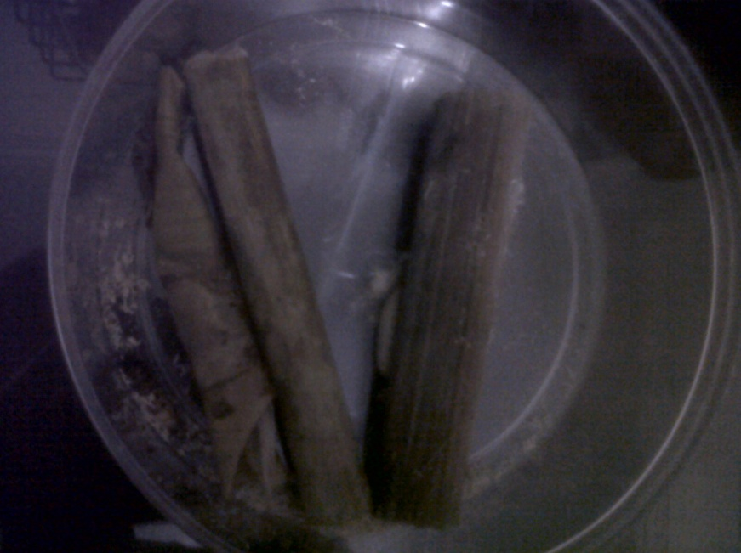

The observer find out it died with the black color all over it’s skin.
It paralyzed, because it is not suitable to live outside the bamboo. It get a disease, it’s body become black

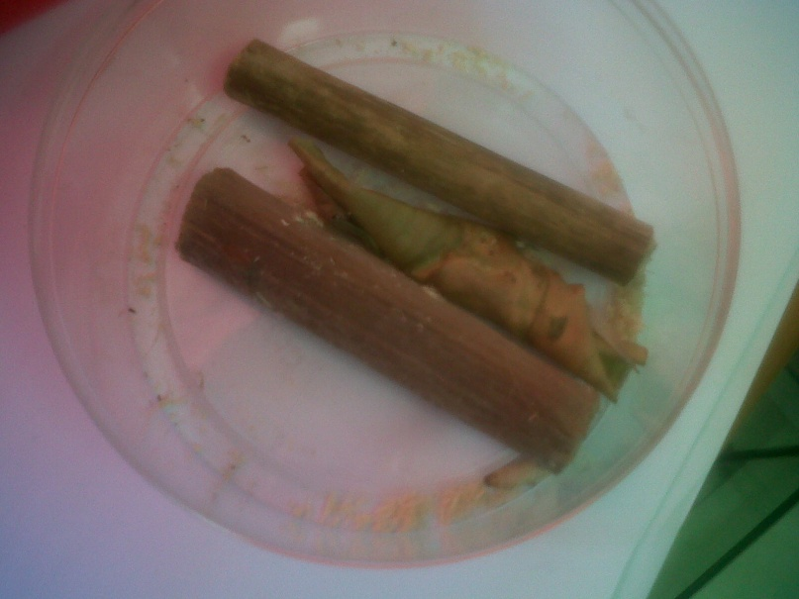
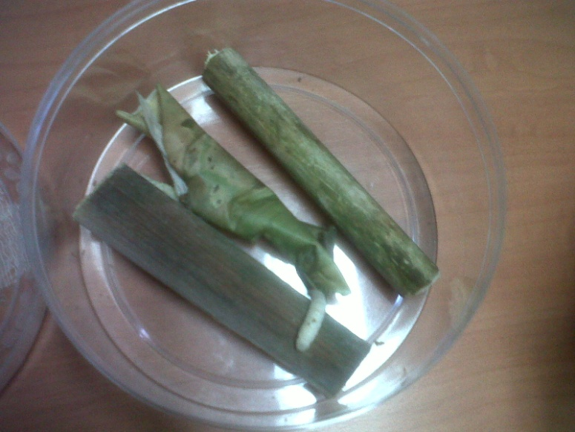

it can’t come back inside the bamboo because the entrace closed with strings made by the caterpillar inside. So they would die soon without food
Another caterpillar get out of the bamboo
One of the worm that got out of the bamboo to explore,
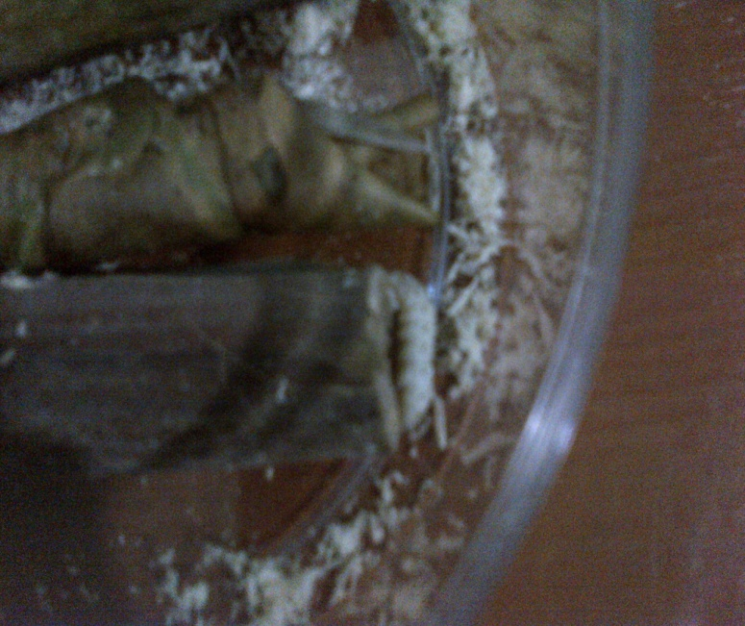
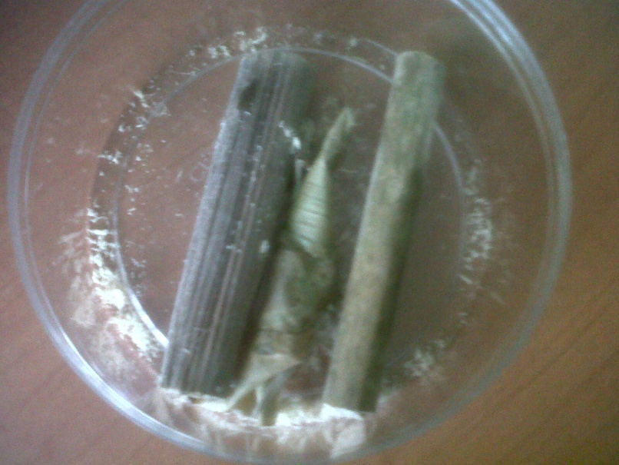

The caterpillar tried to get inside the bamboo, but it can’t because the string block the path
One of the caterpillar is inside the leaves and doesn’t came out for a long time

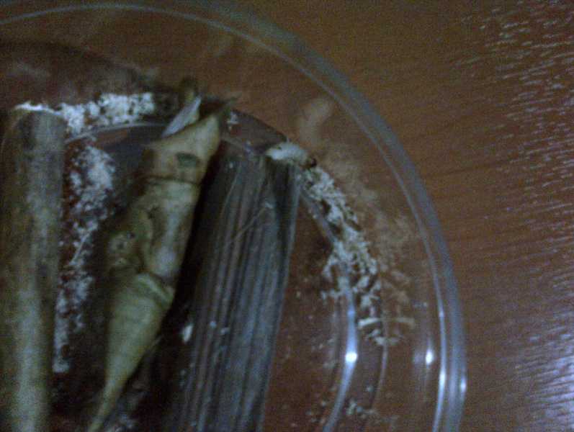
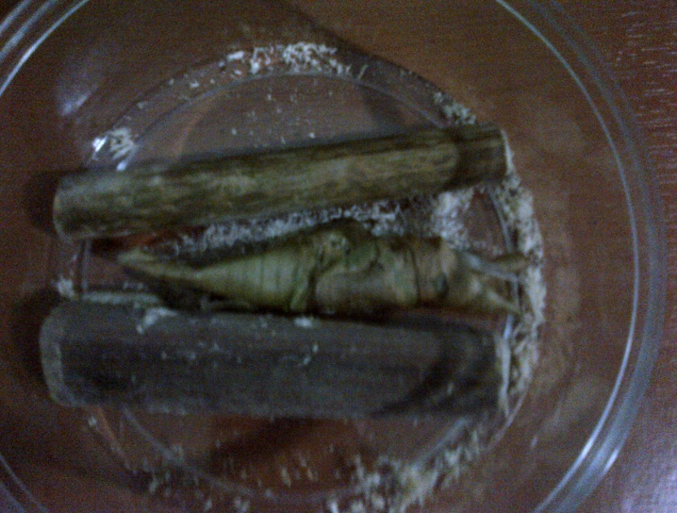

The caterpillar started to get weaker outside the bamboo
The caterpillar outside the bamboo is getting weaker, but could still explore it habitat

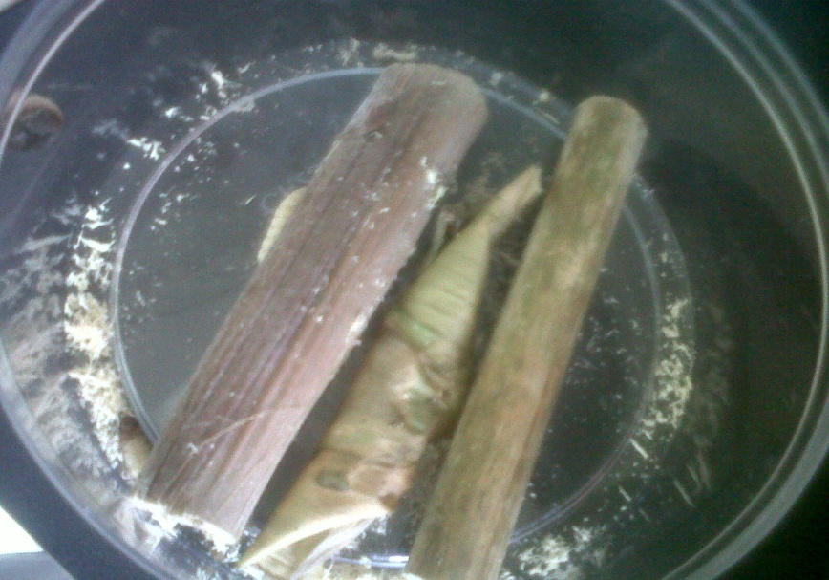
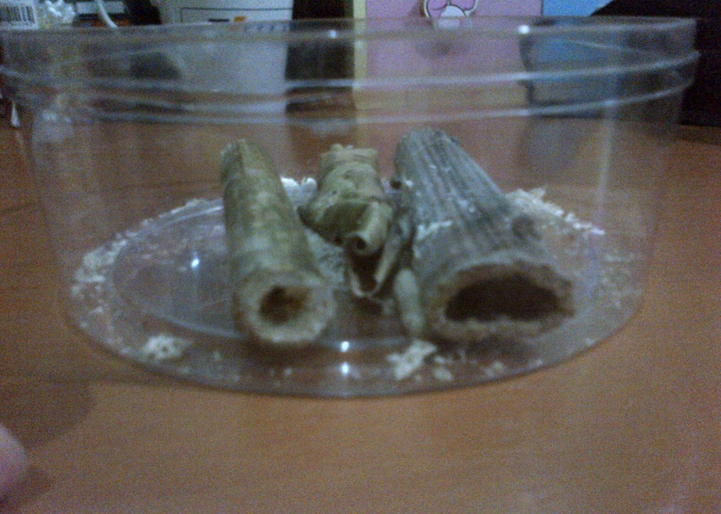
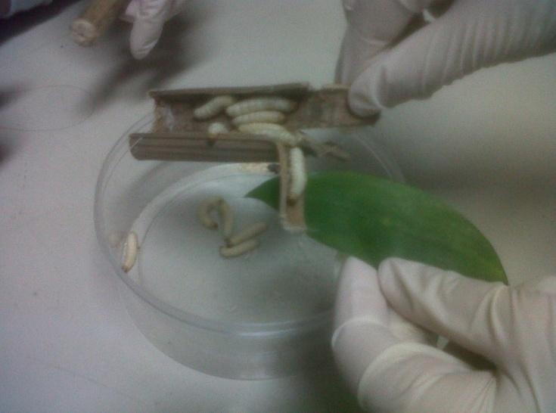
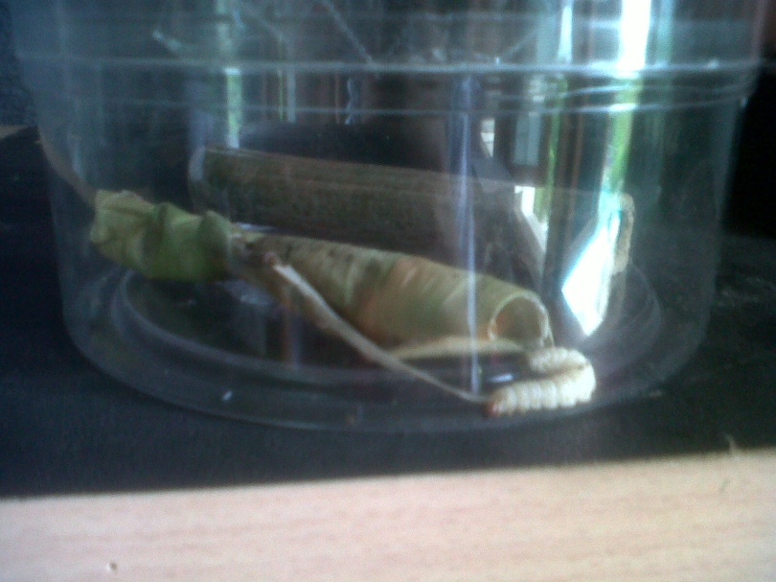
The weak caterpillar is wondering around, it still have strenght to survive in couple of days

The caterpillar didn’t came out yet from the leaf. The string they made is deep inside the bamboo, can’t be seen easily. This was how it looks like in the final week.

The group finds out that inside the bamboo was full of caterpillar. The caterpillars inside the bamboo could survive because inside the bamboo is dark (they don’t like lights), warm, the surface of the bamboo is their food (they absorb the surface to get the juice from the bamboo), and it is just a confortable place for them.
At the end, the weak caterpillar and the caterpillar inside the leaf died in the last week because it doesn’t have enough strenght. Their suitable habitat and food is inside the bamboo

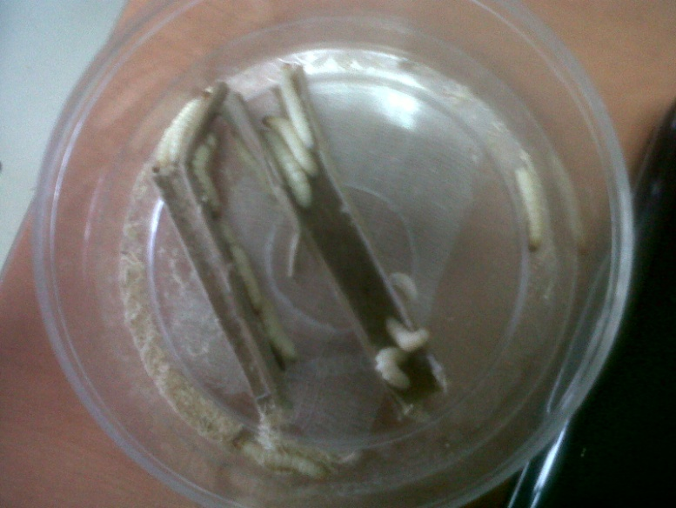

The remaining caterpillars, there are 16 caterpillar
The research proofs that caterpillar needs a warm and humid place to live like the bamboo and it has proven right that the caterpillar need those requirement.The wax worm are strong, they survive easily if it stay in bamboo with 30 degrees celsius. The wax worm made a string like a wall to the entrance/hole of the bamboo, so it could be warm inside the bamboo and to protect it self. All caterpillars inside the bamboo survived and live for 4 weeks because their food are also inside the bamboo. The wax worm likes to absorb the inside surface of the bamboo to get the juices from the bamboo. The caterpillars that are not inside the bamboo fail to survive because they don’t have food to eat and outside the bamboo is colder, but they are strong, even without food and stayed in a cool place the wax worm can live within 2 weeks.
So, here is the conclusion made by the group:
- Bamboo with tubes is a g ood place to use for the Wax worm to live because it’s a warm place and included food inside it
- Wax worm lives longer then the unknown caterpillar, because the unknown caterpillar are so weak as can be seen from their size
- Wax worm can live only if it’s warm and humid
- The research is right about using the baby cereal as their food and the bamboo.
- Baby cereal powder disadvantages: smells bad and dirty which make them unconforatble. The bamboo juices is better because they are simple (not dirty), didn’t smells bad at all, and many capacity of the juices inside the bamboo to live for 4 weeks.
- With 16 wax worms inside the bamboo, they completely survive because the bamboo fullfill their needs.
- It could even live for a long time (more than 4 weeks) if it stayed inside the bamboo
- If all the wax worms are inside the bamboo, no one would die.
- The observer accomplish the task apart from the casualties of the caterpillar
- For improvement try to get a big bamboo so it fits many wax worm
- Get more bamboo with tubes to go inside so the wax worm will all have their habitat to live and survive

Irawan. Berternak Ulat Bambu/Bumbung. Kreatif Kerja. Saturday, 24 September 2011. Web Media. 23 April 2012. <http://kreatifkerja.blogspot.com/2011/09/beternak-ulat-bambu-bumbung.html>
Parris, Lisa. How to Grow a Wax Worm Farm. eHow. Web Media. 18 May 2012. <http://www.ehow.com/how_4883981_grow-wax-worm-farm.html>
Terry, Sarah. How to Raise Waxworms. eHow. Web Media. 21 May 2012. <http://www.ehow.com/how_5075331_raise-waxworms.html>
Keeping and Breeding Waxworms. Tricia's Chinese Water Dragon, Reptile and Amphibian Care Page. Web Media. 21 May 2012. <http://www.triciaswaterdragon.com/waxworms.htm>

