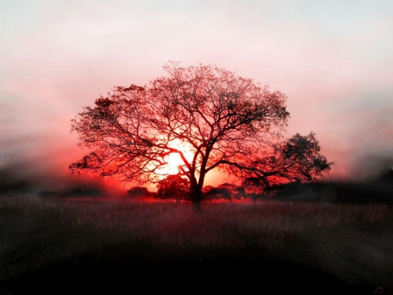
A Poison Tree
Page 10
by William Blake

I was angry with my friend:
I told my wrath, my wrath did end.
I was angry with my foe:
I told it not, my wrath did grow.

And I watered it in fears
Night and morning with my tears,
And I sunned it with smiles
And with soft deceitful wiles.

And it grew both day and night,
Till it bore an apple bright,
And my foe beheld it shine,
And he knew that it was mine,--
And into my garden stole
When the night had veiled the pole;
In the morning, glad, I see
My foe outstretched beneath the tree.

Analysis

The main theme in this poem is anger leads to self destruction. It is how an anger can actually grow more than it to a poison tree. William Blake giving the main theme about anger from “I was angry with my friend:I told my wrath, my wrath did end. I was angry with my foe:I told it not, my wrath did grow.” This shows that he can overcome his anger with his friend. But his anger starting to grow since his angry with his foe and he can’t overcome his wrath and it grow with hatred to a deadly poison tree. It also shows that the author’s angers is hidden in his mind that grow to a poison tree. But it leads to destruction; “In the morning, glad, I see My foe outstretched beneath the tree.” William Blake’s anger grows to a very powerful hatred and it desire to see his foe dead. The destruction which results from anger is spiritual. William Blake is happy to see his foe dead, and that causes the author to be spiritually affected as sinner.

In this poem William Blake use metaphor comparing anger with a plant. In the first three stanzas Blake tells us how he describe his anger and wrath that is not controlled and could grow into a poison tree that is watered and sunned. One of the metaphore used is in the second stanzas. “And I watered it in fears” and “And I sunned it with smiles.” It means that he watered his anger with fears and sunned it with smiles to grow his wrath, like we watered a plant to grow and how plant grow by being sunned. This helps me to understand the process of growing his anger like a plant with hatred inside him to a poison tree. Another example would be “And it grew both day and night, Till it bore an apple bright.” It tells me the description of hate that keep on growing when hatred is inside him. When not controlled it transform into deadly as a poison tree with a poisoned apple. It metaphorically shows growing his anger into a poison tree. So basically the author’s wrath is the poison tree.

