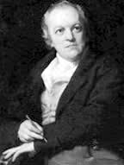
Geral/8.1
The Fly
By William Blake
Little fly,
Thy summer’s play
- Born in London on November 28, 1794
- Hometown: London

- He died in the year 1827

- He published his most popular collection, Songs of Innocence, in 1789 and followed it in 1794, Songs of Experience

- In 1816 he was mentioned A Biographical Dictionary of the Living Authors of Great Britain and Ireland, published in 1816

- The Song of Innocence and Experience was read by Samuel Taylor Coleridge and considered William Blake a “man of Genius”.
My thoughtless hand
Has brushed away.
Am not I
A fly like thee?
Or art not thou
A man like me?
For I dance
And drink and sing,
Till some blind hand
Shall brush my wing.
If thought is life
And strength and breath,
And the want
Of thought is death,
Then am I
`
A happy fly,
If I live,
Page 9
Or if I die.

http://www.poets.org/m/dsp_poem.php?prmMID=20210

